Barney Prever 12WA
20243@jfs.brent.sch.uk
Computer science coursework

Contents
Contents 1
Section 1 – Analysis 2
Introduction 2
Stake Holders 2
Research 3
Essential Features 4
Driving 4
Levels 5
Customisation 5
Points system 6
Limitations 6
Own knowledge 6
Processing power 6
Art 7
Requirements 7
Game requirements 7
Hardware/software requirements 7
Success Criteria 8

Section 1 – Analysis

Introduction
Using the ‘pygame’ module in Python, on VS code I am going to code my own take of a top-down drifting simulator. The game will allow players to control and customise a car, choosing between racing around a track in the quickest time possible or playing through and completing endless levels. Crashing into corners/track borders will hinder or completely stop progress, depending on how many times the car has already hit a wall. There will be icons to collect on the track that can reduce time, or offer more points depending on the mode selected – points will be rewarded for long streaks on endless mode, and faster times on race mode, as well as for minimal damage in either. These points can be used to upgrade/customise the car, making it better looking and faster.
This project is ideal for a computer – firstly, the physical cost of coding such a game is next to nothing, compared with attempting to build anything remotely similar in real life. For example, simulating an engine, customising a car, and racing and drifting round a track have practically no other alternatives to the real-life options – other than being recreated on a computer. Additionally, many variables, such as speed, acceleration, time taken, damage to car, and many others will need to be stored and updated continuously, which is most easily done using a computers vast processing power.

Stake Holders
I created a survey using microsoft forms, and asked several people their opinions on aspects of my game. I also interviewed one candidate.
I firstly asked peoples ages. The majority of respondents were 15-17 – 46% were 17, and 28% were 16. One respondent was 15, and the remaining respondents were aged 50+. The one candidate I interviewed was also 17. My game is targeted at people my age – 15-17 – so this was perfect. However, it is also useful to have data from other age groups, as I can ensure that other groups will have some form of interest and want to play.
I then asked if they had played a racing game before. The majority of respondents had – only 21% hadn’t. This meant I was getting useful information, as most of the data is coming from people who have experience with racing games and know what they want, but I’m also getting the input of people who are unbiased by previous experiences.
I then asked 4 questions about preference toward certain features in my game. First, I asked whether car customisation was more important or car modification, and 86% of respondents selected car modification.
My second question was regarding gui design or gameplay details, like smoke from tyres whilst drifting and marks left behind after drifting. 71% of the respondents said that the gui design is more important to them than the gameplay details.
My third question asked if people preferred having lots of levels to complete, or one long endless level, and 79% of people voted for having lots of levels.
My fourth question was based around the point system, asking if people thought it was better to get points based off of one thing or based off of multiple different variables – 64% of people thought it was better to have multiple different things contributing to the points awarded.
Overall, this survey was extremely useful, as it helped me see what players would value in a drfiting/racing game, and during development stage it will help me choose what I need to focus on, so that I wont waste time on unnecesary features.

Research
The main design from the game will be based on the design of ‘Drifters don’t break’, which is currently being designed by HackoonDev.
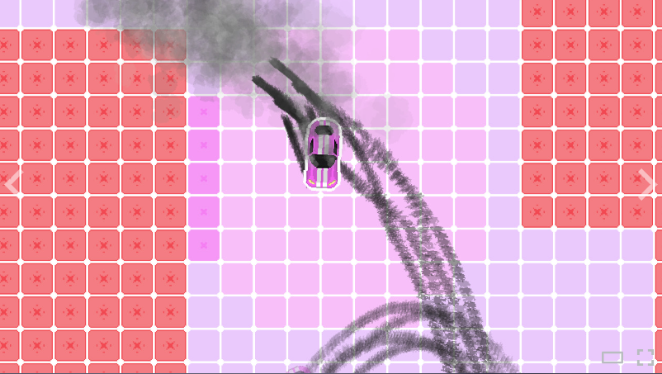
Figure 1 - a screenshot taken from the steam page of 'Drifters don't break'
I really like the simplistic style of the top-down drift aspect of the game – a car sliding around obstacles. Like in ‘Drifters don’t break’, the game will focus around the car – the map will move, whilst the car stays centered, creating the illusion of driving. Additionally, as shown in figure 1, I like the smoke and tyre marks created by ‘drifting’ – adding to the illusion of the car moving. I will have to ensure that the map moves around smoothly, and that if the car collides with a wall it is properly registered – perhaps by coding the walls as separate entities. I feel that this will be a challenge to code, but not beyond me, and if done right will make the game more exciting than if the car was moving and the map was still.
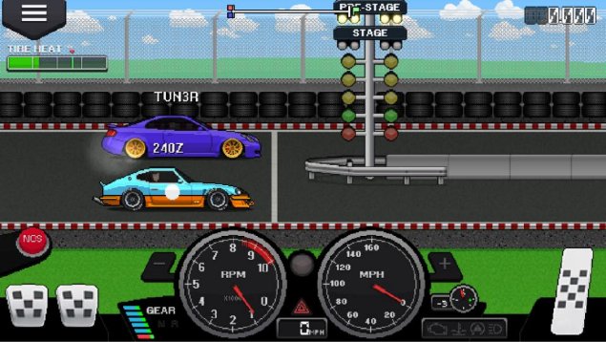  Figure 2- a photo taken from online of 'Pixel car racer' | I also like the pedal and dashboard design from ‘Pixel car racer’ (figure 2). The right pedal is the accelerator, and can be pushed down to accelerate – the same can be done for the clutch (far left) and brake (near left). Additionally, when the key corresponding to each pedal is pressed the on-screen pedal goes down, simulating being pressed. This would require me to ensure that if the pedal is clicked or a key pressed the car would respond accordingly, and the pedal would move slightly. I feel that this isn’t difficult to code, but would give the game a more enjoyable feel.

Additionally, I really like the speedometer and tachometer design from ‘Pixel car racer’ (figure 2). Adding it in would require a base design for a background, with an image of a needle rotating around a point according to a given speed/rpm. This would be mildly challenging – the hardest part would be ensuring the needle is accurate in where it is pointing – but this could be done fairly easily by finding the angle from 0-max point, and setting the needle to the correct percentage of that angle ( the percentage being the current speed/rpm divide by the total speed/rpm *100). I feel that again, the implementation of this feature will give the UI of the game a more exciting, action-packed feel, allowing the player to feel more engrossed.
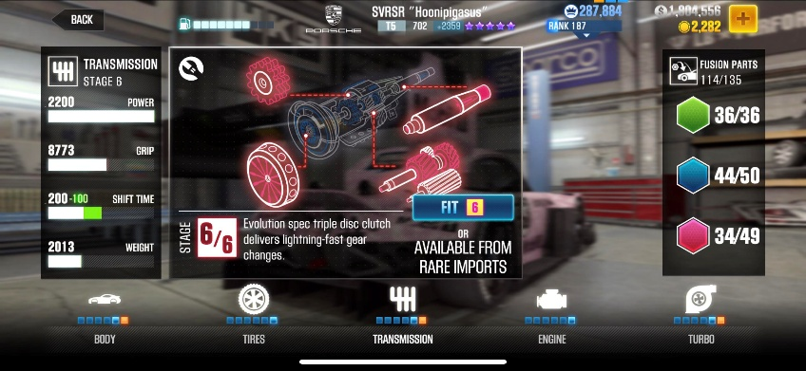  Figure 3 - An example of one of the upgrades from CSR2, taken from online. | 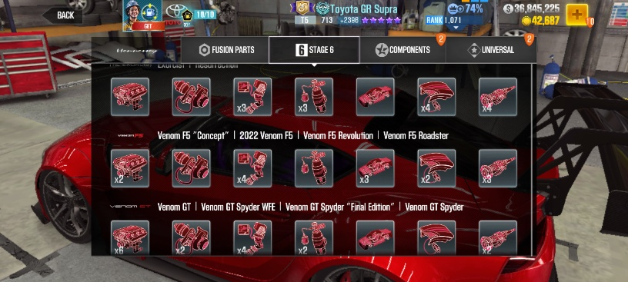  Figure 4 - An example of all the upgrades available in CSR2, taken from online.
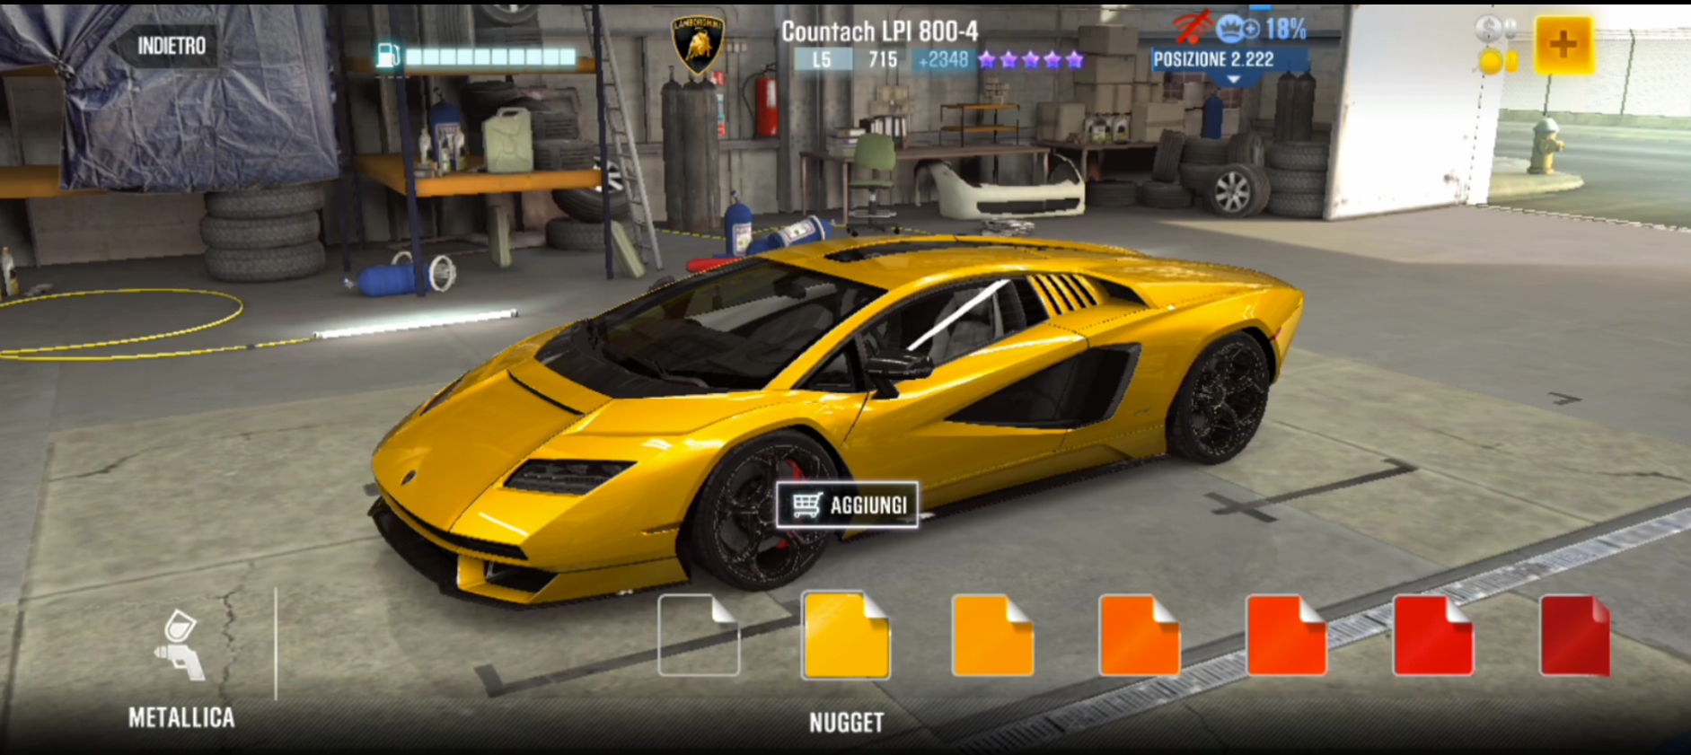  Figure 5 - an example of the customisation options for cars in CSR2, screenshot from a youtube video. |  | Furthermore, I really admire both the upgrade system (figure 3, 4) and customisation system (figure 5) from CSR2. I like how the upgrade system mirrors real car upgrades – it isn’t just upgrading speed, or acceleration, or handling etc – each upgrade will affect multiple variables, meaning you will maybe have to sacrifice power for better handling – you can fully customise the feel of your car. However, this might be very difficult to code – although I am ready for the challenge. Most likely I will create a simplified version, with fewer parts – but still a more lifelike option than simply upgrading variables.

This will require different upgrades to be created as options that can be selected, ensure they can only be selected the desired amount of times, and ensure that when selected they will affect the desired variables of the car. This means that the user has something else to aim for – besides moving through levels and getting the best possible score, they can also aim to max out all upgrades.
I like how the customisation system isn’t too complex – no super fancy designs or patterns – but still allows a fair bit of choice. For example, in figure 5 you can see the paint style – metallica – and a range of colours to choose from. Other paint styles could be matte, gloss, satin etc. This allows the player to customise the car, but isn’t too difficult to code – simply changing the sprite of car shown. I can use a library to connect a string e.g “Green” to the image I want to be shown, then use a separate variable e.g “CarColour” to store the current car colour and ensure the correct colour is displayed. Getting the different types to appear as I want could be challenging, but since I’m using different sprites, in designing the sprites I can just create them to appear as I want.
Overall I don’t think any of these features will be hard to add - since I feel my python ability is farily strong, and I’m well versed in using pygame – and that they will make the game much more enjoyable, exciting and immersive to play.

Essential Features

Driving
As a racing game, driving is obvioulsy an essential feature. However, since the game is focused around drfiting, a focus will have to be placed upon how the car reacts with the surface it is driving upon. The easiest route to take would be having one surface, with a constant coefficient of friction with the wheels of the car. I could store the force the car is currently generating and its direction under two variables, the force that is acting on the car and its direction under another two, and use python’s math library to calculate a resultant force. Then, if the car is trying to drift – which I can check by comparing the generated forces direction witht the acting forces direction, using the resultant force, as well as using the formula for friction (F≤μR) which will be dependent on the weight of the car, to calculate how much it will drift. This will create an exciting driving experience, where the car is reactive to how the player acts and moves it.
Seperately, the friction will also affect the power the car generates whilst driving normally.
However, a harder route, but one that would make the game more fun as a whole, would be to add different surfaces – like ice, or dirt – and different types of tyres, to increase customisation and add to the racing experience, as well as making levels more interesting.
Driving is fairly easy to implement compared to drifiting – use the variable that calculates resultant force (as mentioned earlier), store the acceleration of the car (which can be calculated using F=MA) store the velocity of the car (which increases/decreases with the acceleration), and use the variable that stores the direction – combine all of these to make the car move. Seperately I can use python’s pygame library to register when buttons are pressed, and make them work for specific processes – e.g forward arrow/W key = move forward, spacebar = break etc.
Overall, I will start with the most basic driving and drifiting mechanics, ensuring it works consistently, then if I have the time, I will implement additional features.

Levels
Although the driving feature is undeniably the most important, it goes hand in hand with having playable levels. Ideally, I would like to have two separate driving modes – an endless mode, which allows players to drive for as long as possible, and gain points based off the overall time, and levels, which a player can aim to complete in the fastest time possible. An endless mode would require a map generation, ensuring that it is possible to get through the generated map. Levels would be easier to create, as they would be set, and not require any additional code – but would be limited. However, from my survey, only 21% of respondents prefer endless driving over ‘lots of levels to complete’ – therefore, in developing my game, I will prioritise creating multiple different levels to play, in order to cater to user preference. In creating the levels, I will find a way to create walls – one method ive used previously in other game design is to store the players location in an array, and have the walls also stored in an array, moving the player accordingly and ensuring they cant pass through walls. However, that was a very flawed system, and it may be easier to use images of walls and use the .collidepoint function that comes with the pygame library in python to check for collisions with the car. This would be the most complex part of level design – timing the players runthrough would be relatively easy, as I could use the time library from python, and creating the levels would not be hard either – the main aspect is getting working walls.

Customisation
I would like to have both the option to customise how a car looks, and modify and upgrade it to be faster/handle better. In my survey, 86% of respondents opted for modifying and upgrading the car over customising its looks, and so I will prioritise implementing that feature. However, for either case it is not a difficult feature to implement – but focusing on one will allow me more time to implement other essential features. To implement car modification, I will create many different ‘parts’, that can be viewed in a ‘shop’ section of my game, that will affect certain aspects of the car – e.g changing the exhaust system, or switching out the seats in the car. They wont necessarily be visual, but they will affect variables relative to the car, such as weight, or acceleration.
Since a car customisation feature isn’t as important to users, it won’t be a priority, but if I do add it I’ll begin basic – creating different images of the car in different colours, or creating different cars entirely to allow the user to choose.

Points system
There are many directions when implementing a points system. I could simply reward points relative to the user’s time taken to complete a level – but if I chose to implement an ‘endless mode’, I would need to find another way of rewarding points – or leave it to be a ‘practise’ mode, that reward no points.
In my survey, 64% of respondents opted for points based off of multiple different variables, over only one variable (like time taken). This is definitely the better choice, and so in rewarding points I will create an algorithm that gives points relative to several different things. Firstly it will be focused on time taken – in levels it will be for shorter times and in endless (if created) it will be for longer times. Secondly, additional points will be given for ‘high scores’, which will be recorded and saved. Also, depending on how many collisions you have whilst driving, points will be affected – points will be deducted if you repeatedly crash. A potential idea could be ‘drift points’ - bonus points for long/impressive drifts, so you aren’t just slowing down as much as possible to avoid drifiting - although that might be hard to calculate.
Any points will go toward upgrading the car – that way there is a reason to get points, and something to use them for.
Overall, I’d like to reward the player for completing levels quickly and not crashing – and anything else I want to reward the player for that I identify during development will be added to the algorithm.

Limitations

Own knowledge
I lack many skills that would be incredibly useful in regards to creating and designing the game, such as functions and libraries that could be used in python, designing tables and data bases that could be used to store data, creating simple methods and functions that would help the car be more effiicient in moving and drifting round the track, and much more. However, I am very skilled at learning, and the internet has a vast amount of knowledge left by other people in similar situations, so I can use this to my advantage and to help me learn how to do anything I lack knowledge of. This is still a limitation however, as I will have to spend time that could be spent coding, learning how to do certain processes.

Processing power
The coding resources provided by my school are very useful, but do not contain a significant amount of processing power. My own laptop is almost 7 years old, and is mainly for watching tv or writing word documents – it again has a very small amount of processing power. This game will be updating a large amount of variables simultaneously, and as a result will require a lot of processing power. Lacking this processing power means that I may be forced to limit the detail I put into my game, and scrap some features entirely just to make sure the game is still playable and runs smoothly.

Art
I am not a talented artist, and this game will require a fair bit of art. AI is able to generate very impressive art, but it again is limited (as I don’t want to spend any money) and requires very specific prompts to get what is desired. Theres lots of art free to use online, but it isn’t necessarily what I want and will take more time searching for just the right image than if I was able to design it myself. This will limit how the game will look, as if I am unable to design something as to how I envisioned it it won’t be perfect.

Requirements

Game requirements
- A car sprite
- A movement mechanic
  - The player can control acceleration, turning and braking
  - The car has its own statistics that affect its movement
- Several playable levels
  - The levels will have walls that you have to drive around and avoid
  - Crashing into these walls will slow you down/stop you – you wont be able to drive through them.
- A modification system of the car so it can be upgraded
- A points system by which the player is rewared relative to several different variables
- A creative GUI
  - Features like spedometer and pedals
  - Pause button
  - The car stays in one place whilst the map moves around it – creating the illusion of movement.

Hardware/software requirements
I will write the code on VS code, and therefore the hardware/software requirements will be the same as what would be required to run Visual Studio Code version 1.116.0.
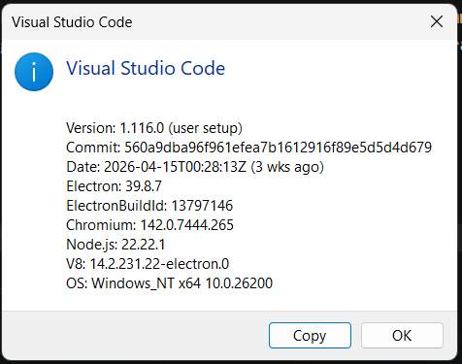
Figure 6 - a screenshot taken from the 'about' section of my current VS code
Primarily required will be a laptop with a working keyboard and mouse – on top of that the laptop must have the necessary operating system to run the same or newer version of visual studio code that I used to create the game. The laptop will need the pygame library downloaded, or space to download the library, and any other libraries I choose to use. It will also need enough processing power to run the game – as much as my laptop has.

Success Criteria
1 – I want to implement a system that allows a player to control a car, accelerate, turn and brake, drift when appropriate. This will be measured using screenshots.
2 – I want to have at least 3 levels that the player can drive around, with walls to avoid that the player can’t drive through. I also want the map to move around the player, creating the illusion of driving. I will measure this using screenshots as well.
3 – I want to have a system that allows the player to upgrade the car and customise its modifications to their preference. This will also be measured using screenshots.
4 – I want to create a GUI that looks appealing and is interactive, such as the one from Pixel Car Racer. This will be measured using a survey, asking players whether they feel the GUI makes the game better or not.
5 – I want to create a system that awards points to the player based off of multiple different things. This will be recorded using both a screenshot and a survey, asking players if they feel points have been awarded fairly.

